ADVANCED READING COMPREHENSION
HS3 AND ABOVE
LUDĪ/SCRAM 2019

Based on the texts below, choose the best answer for the following questions. Numbers to the left are line numbers.

I.ULYSSES FACES CIRCE

- Ulixēs cum comitibus suīs ad īnsulam Aeaeam
- nāvigāvit. habitābat ibi Circe, dea artīs magicīs
- nōtissima. Ulixēs, in ōrā manēns, comitum nōnnullōs
- in interiōrem partem īnsulae mīsit. ex quibus ūnus
- sōlus revēnit, quī tristissimā voce tālia dīxit,’vix
- ā tē discesserāmus, ubi magnam vīllam in mediā silvā
- vīdimus. prope portās errābant multa animālia, sed
- nōs nōn oppugnābant. tum domō excessit fēmina
- pulcherrima, quae nōbīs cibum vīnumque dedit. tum
- repente virgā comitēs meōs ferit et in porcōs
- vertit. ego sōlus domum nōn intrāveram, itaque ad tē
- revertī poteram.’

- Circe’s claim to fame (2-3) is that she is a
a. maiden b. wife c. friend d. witch

- How many men did Odysseus send inland (3)?
a. none b. many c. some d. only one

- How many men returned (4-5)?
a. one b. all of them c. none d. a few

- What was strange about the animals in the forest (7-8)?
  - They were wandering aimlessly.
  - They did not attack.
  - They stayed near the house.
  - There were so many of them.

- What does Circe NOT do in lines 8-11?
  - She gave the men food and wine.
  - She hit them with a stick.
  - She turned them into pigs.
  - She offered them a very beautiful woman.

- How does the speaker escape Circe (11)?
  - He ran.
  - He did not go into the house.
  - He went home.
  - He had already returned to Odysseus.

II.ULYSSES FACES CIRCE – continued

13. hōc dictō, Ulixes ad virōs currere incēpit. Mercurius
14. subitō apparuit ut auxilium ducī offerret. dedit Ulixī
15. herbam magicam, et Circe frūstrā artēs suās contra
16. Ulixem exercuit. tandem comitibus formam humānam
17. reddidit.

- What was the first thing Odysseus did after hearing the story (13)?
  - He spoke out.
  - He began to run to his men.
  - He called upon Mercury.
  - He asked for help.

- What did Mercury NOT do in this story (13-15)?
  - appeared suddenly c. gave a magic herb
  - offered help d. threatened Circe

- What did Circe do in the end?
  - ran away c. cursed Odysseus
  - cried d. reconstructed the men

CONTINUTE TO THE NEXT PAGE!
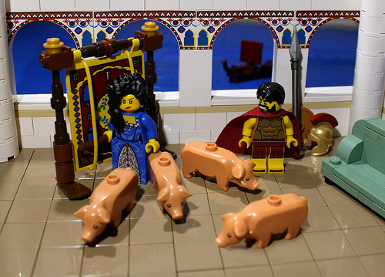
III. The Deer in the Woods (Anonymous, from Medieval Lit.)

1. cervus, bibēns dē fonte, sua cornua magna ut vīdit
2. in aquā, plūrimum laudāre coepit; crūra sed tenua
3. vituperāvit. quod cum faceret, vēnātōris vocem audīvit
4. et canēs repente lātrāre. fugā cervus per campum
5. dīcitur ēvāsisse Molossōs. at ut silva eum suscēpit,
6. magnitūdō cornuum vēnantibus eum retinuit. tunc
7. mortem suam vidēns, ait, “quae mihi erant ūtilia
8. vituperāvī et dēceptiōsa laudāvī.

crūs: leg suscipiō: receive
dēceptiōsus: deceitful vēnātor: hunter
Molossus: hunting hound vituperō: criticize

- What was the deer doing in line 1?
a. sleeping b. drinking c. fighting d. running

- He was looking at his(1)…
a. feet b. tail c. horns d. large eyes

12.How did he feel about them/it (1-2)?
a. liked ’em b. feared ’em c. hated ’em d. can’t tell

13.What did he think about his legs (2-3)? They were…
a. true b. beautiful c. thin d. crooked

14.The best translation of quod cum faceret (3) is…
a. Because he did this c. Although he was doing this
b. When he had done this d. While he was doing this

15.What did he hear (3-4)?
a. a hunter and dogs c. voices
b. hunters and a dog d. a sudden laugh

16.What did the deer do (4)?
a. froze b. wept c. fled d. attacked

17.The deer went to (5)…
a. the city b. the woods c. a camp d. the sea

18.What problem did he run into (6)?
a. His horns were too big. c. Hunters wanted his horns.
b. A crowd stopped him. d. He was too tall.

19.The essence of the last sentence “quae mihi erant ūtilia vituperāvī et dēceptiōsa (deceitful) laudāvī” (7-8) is…
a. I criticized the bad and praised the good.
b. I praised the bad and criticized the good.
c. I was not useful and, though deceitful, was praised.
d. It is right to praise the good and criticize the bad.

IV. The Trojans meet Sinon, who has been planted in the swamp by the Greeks to be found by the Trojans.

145. his lacrimis vitam damus et miserescimus ultro.
146. ipse viro primus manicas atque arta leuari
147. vincla iubet Priamus dictisque ita fatur amicis:
148. 'quisquis es, amissos hinc iam obliviscere Graios;
149. noster eris mihique haec edissere vera roganti:
150. quo molem hanc immanis equi statuere? quis auctor?
151. quidue petunt? quae religio? aut quae machina belli?'
152. dixerat. ille dolis instructus et arte Pelasga
153. sustulit exutas vinclis ad sidera palmas:
Vergil, Aeneid, II.145-59

artus: tight exutus: freed
edissero: tell miseresco: feel pity

20.The ipse (146) refers to…
a. viro b. manicas c. vincla d. Priamus

21.What do the Trojans do for Sinon in 146-7?
a. tie him up c. lift him up by his chains
b. tighten the chains d. loosen his bonds

22.The best translation of quisquis es (148) is…
a. Who are you? c. What is this?
b. Whoever you are. d. Whatever this is.

23.What does Priam say in 148-9?
a. Forget the Greeks and tell us the truth.
b. Don’t forget the Greeks, but tell us the truth.
c. You are our prisoner so tell us the truth.
d. You are now a Trojan so you always tell the truth.

24.The figure of speech in 149(noster…roganti) is…
a. anaphora b. litotes c. chiasmus d. synchesis

25.In lines 150-151, which question is NOT asked?
a. Why have they built this huge hulk of horse?
b. Who came up with the idea?
c. Should we take it into the city?
d. Is it an offering or a war machine?

26.In line 152, the word dolis means…
a. by tricks b. by grief c. for pain d. for gifts

27.What is Sinon doing in 153: sustulit..palmas
a. throwing logs c. crying
b. praying d. threatening

V. The Trojans Meet Sinon - continued

154. 'vos, aeterni ignes, et non violabile vestrum
155. testor numen,' ait,'vos arae ensesque nefandi,
156. quos fugi, vittaeque deum, quas hostia gessi:
157. fas mihi Graiorum sacrata resoluere iura,
158. fas odisse viros atque omnia ferre sub auras,
159. si qua tegunt, teneor patriae nec legibus ullis.’

hostia: victim tego: be hidden

28. What are the aeterni ignes of line 154?
a. hearthfires c. stars
b. torches d. lampstands

29. What is the best translation of omnia ferre sub auras (158)?
a. to bring all things into the open air
b. that all things are being carried up to the air
c. to bring everything to your ears
d. that all things turn to gold

30. What country does he mean in the last line?
a. Troy b. Greece c. Italy d. Sicily

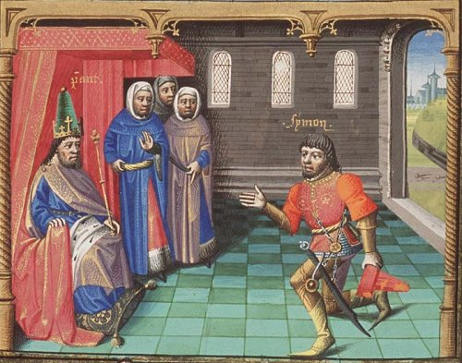
Answer Key for Advanced Reading Comp. 2019 Ludi/SCRAM

1.D
2.C
3.A
4.B
5.D
6.B
7.B
8.D
9.D
10.B
11.C
12.A
13.C
14.D
15.A
16.C
17.B
18.A
19.B
20.D
21.D
22.B
23.A
24.C
25.C
26.A
27.B
28.C
29.A
30.B

